FINAL PROJECT REPORT
Smartphone Usage, Digital Addiction & Well-Being Analytics

Project Detail | Information
Dataset | Smartphone_Usage.csv
Records | 7,500 user records
Attributes | 16 attributes
Target Variable | addicted_label
Primary Tool | Microsoft Power BI
Calculated Field | Age Group

Project focus
Understand smartphone addiction prevalence and examine how screen-time behavior, lifestyle habits, stress, and demographic characteristics relate to addiction classification.

1. Introduction

1.1. Project overview
This project analyzes smartphone usage behavior across 7,500 users using Microsoft Power BI. The dataset contains 16 attributes covering demographics, daily usage behavior, notification and app-open volume, lifestyle habits, and addiction status. The analysis is designed to help product and research teams understand smartphone addiction prevalence and the usage patterns associated with it.
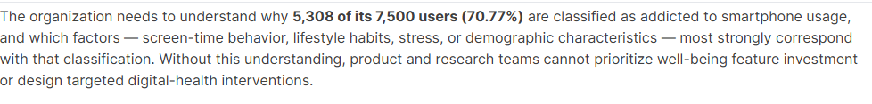

1.2. Objectives
- Quantify overall and segment-level addiction prevalence across gender, age group, and stress level.
- Identify factors most associated with smartphone addiction risk, including screen time, social-media hours, notifications, sleep, and stress.
- Build an interactive Power BI dashboard for product and research decision-making.
- Use the calculated Age Group field to support cleaner segment-level analysis.
- Deliver clear, actionable insight to support digital well-being interventions and healthier usage habits.

2. Project Initialization and Planning Phase

2.1. Define Problem Statement
The organization needs to understand why 5,308 of its 7,500 users (70.77%) are classified as addicted to smartphone usage, and which factors—screen-time behavior, lifestyle habits, stress, or demographic characteristics—most strongly correspond with that classification. Without this understanding, product and research teams cannot prioritize well-being feature investment or design targeted digital-health interventions.

2.2. Project Proposal (Proposed Solution)
The proposed solution is an interactive Power BI analytics dashboard that combines KPI cards, categorical comparisons, a donut chart, and a relationship/scatter visualization. Users can filter the analysis by gender, addiction level, and Age Group. The dashboard summarizes overall usage and addiction indicators while allowing segment-level exploration.
Proposed analytical approach
Load Smartphone_Usage.csv → review and prepare fields → create Age Group → define measures/aggregations → build business-question visuals → add filters → validate KPI totals and visual consistency → publish dashboard/report.

2.3. Initial Project Planning
Phase | Planned activity | Output
1. Problem definition | Clarify addiction-related business need and target variable. | Problem statement
2. Data preparation | Review 7,500 records and 16 attributes; prepare analysis fields. | Analysis-ready dataset
3. Data modeling | Create Age Group and required aggregations/measures. | Calculated field/measures
4. Visualization | Build visuals around business questions. | Power BI visuals
5. Dashboard | Combine KPIs, charts, and filters. | Interactive dashboard
6. Validation | Check totals, filters, and visual outputs. | Validated report

3. Data Collection and Preprocessing Phase

3.1. Data Collection Plan and Raw Data Sources Identified
The project uses Smartphone_Usage.csv as the raw data source. The supplied project description states that the file contains 7,500 user records across 16 attributes, covering demographics, daily usage behavior, notification and app-open volume, lifestyle habits, and addiction status.

3.2. Data Quality Report
The available project material identifies the dataset structure and target variable but does not provide a separate numerical missing-value, duplicate, or outlier audit. Therefore, this report does not invent quality percentages. The data-quality focus for the Power BI workflow is field type consistency, categorical consistency, valid numeric ranges, and correct aggregation of user-level records.
Quality area | Project treatment / validation focus
Record count | 7,500 user records reported in the project description.
Attribute count | 16 attributes reported in the project description.
Target field | addicted_label is the target variable (1 = Addicted, 0 = Not Addicted).
Categorical fields | Gender, stress_level, addiction_level, and academic_work_impact require consistent categories.
Numeric fields | Usage, sleep, notification, and app-open fields are analyzed using numeric aggregations.
Derived field | Age Group is used for segment-level analysis.

3.3. Data Exploration and Preprocessing
The project uses the fields defined in the supplied data dictionary. The target variable is addicted_label, while addiction_level provides a severity category. Age Group is used as a calculated field for cleaner age segmentation. The dashboard applies standard aggregations such as count and average to summarize user behavior.
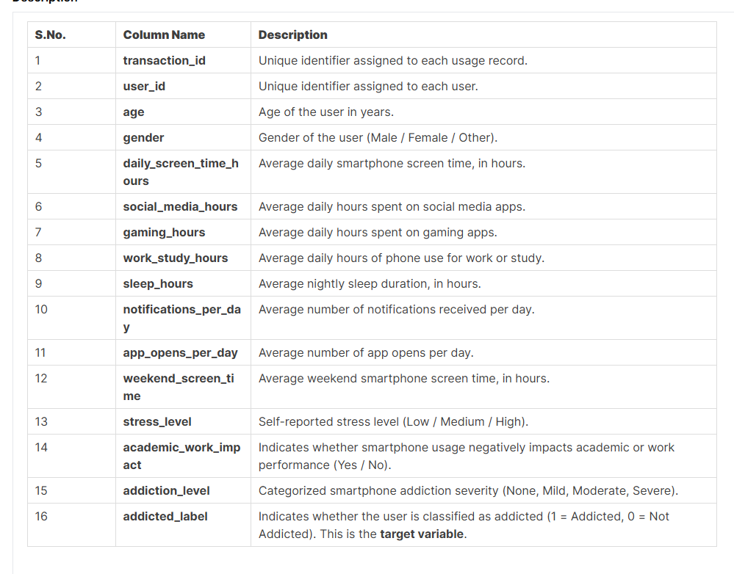
.

4. Data Visualization

4.1. Framing Business Questions
The visualization stage is organized around business questions that connect addiction prevalence with user behavior and demographics.
- What is the overall profile of smartphone users in the dataset?
- How does average daily screen time vary by gender?
- Which addiction levels have the highest number of users?
- How does average daily screen time vary across age groups?
- What is the relationship between daily screen time and sleep hours?
- What proportion of users are classified as addicted?
- How do average gaming hours compare with average social-media hours?
- What are the average daily engagement and usage indicators?

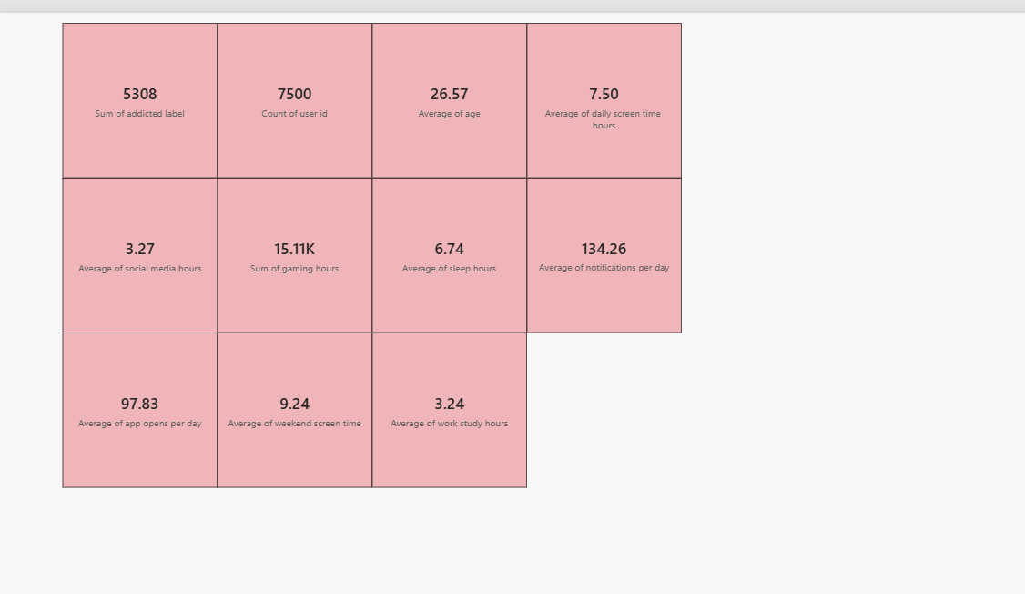
4.2. Developing Visualizations
The dashboard uses KPI cards for headline measures, column/bar charts for demographic and addiction-level comparisons, a donut chart for the addicted/not-addicted split, and a scatter plot for screen time versus sleep. Filters are provided for gender, addiction level, and Age Group.
Business question | Visualization | Main measure/field
Overall user profile | KPI cards | Users, age, screen time, sleep
Screen time by gender | Column chart | Average daily screen time
Addiction severity | Horizontal bar chart | Count of user_id by addiction_level
Screen time by age | Column chart | Average daily screen time by Age Group
Screen time vs sleep | Scatter plot | Daily screen time and sleep hours
Addicted share | Donut chart | Count of user_id by addicted_label
Gaming vs social media | Clustered column chart | Average gaming/social-media hours
Engagement indicators | KPI cards | Notifications, app opens, weekend screen time, work/study hours

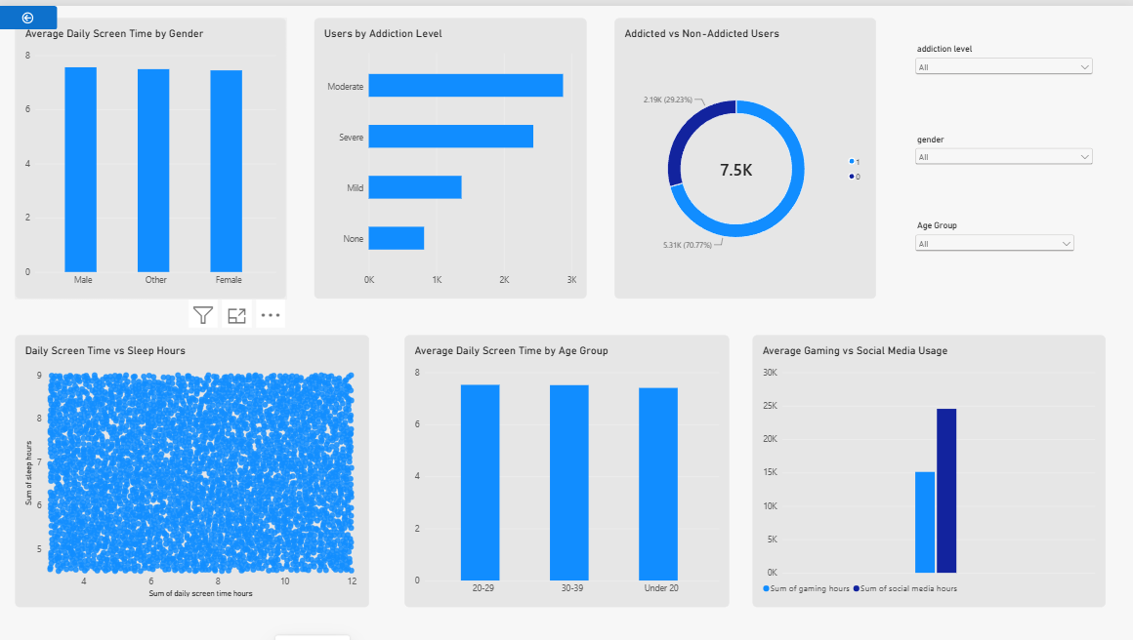
Key report message
The supplied visuals show a high overall addicted-label share (70.77%), high average daily screen time (7.50 hours), and substantial daily notification/app-open activity. Segment charts provide demographic context for further investigation.

5. Dashboard

5.1. Dashboard Design with Insights

Dashboard overview:
This dashboard analyzes digital well-being, smartphone addiction, screen time, and sleep patterns. It shows daily and weekend screen-time usage, sleep hours, addiction levels, age groups, gender, stress levels, and app usage. Overall, the dashboard highlights that addicted users have higher weekend screen time (10.2 hours) compared with non-addicted users (6.9 hours), helping to understand the relationship between smartphone usage and digital well-being.
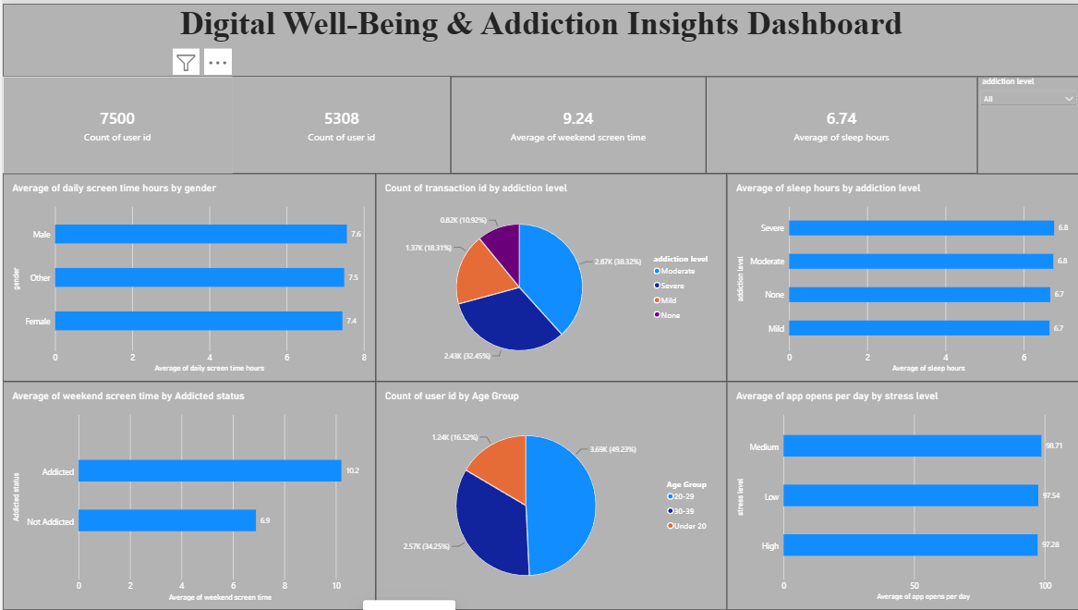
Visualization insights:

The dashboard contains 7,500 users, with 5,308 users classified as addicted.

The average weekend screen time is 9.24 hours, while average sleep is 6.74 hours.

Addicted users spend 10.2 hours on screens during weekends compared with 6.9 hours for non-addicted users.

Average daily screen time is similar across genders, ranging from 7.4 to 7.6 hours.

Moderate addiction represents the largest addiction category, followed by severe and mild levels.

Average sleep remains around 6.7–6.8 hours across addiction levels.

App openings are high across stress levels, averaging around 97–99 times per day.

6. Report

6.1. Report Design with Insights

The report layer is designed to communicate the dashboard findings in a structured business format. It combines the project context, business questions, visual evidence, and key observations so that product and research stakeholders can interpret the analysis without needing to inspect every visual independently.
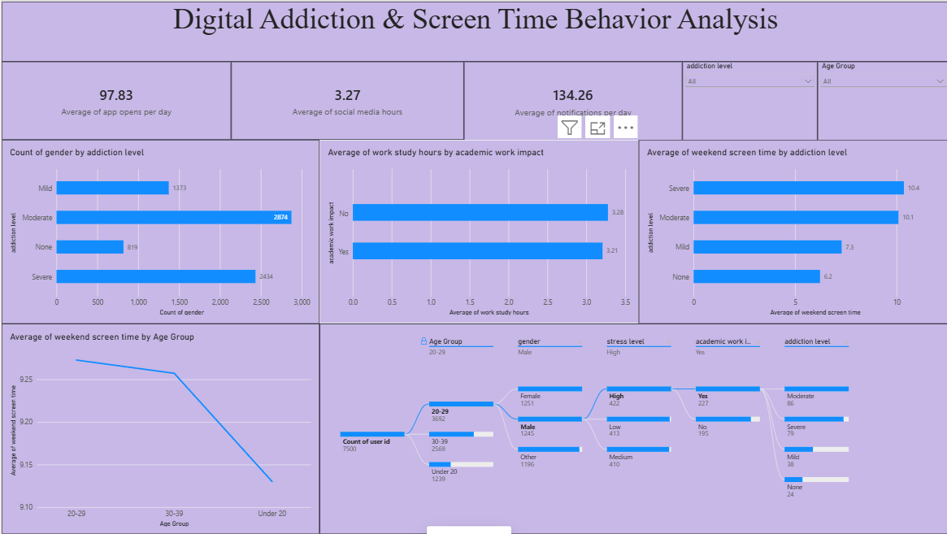

Visualization Insights:
- The dashboard shows high smartphone engagement, with an average of 97.83 app opens and 134.26 notifications per day.
- Users spend an average of 3.27 hours per day on social media.
- Moderate addiction has the highest number of users (2,874), followed by Severe (2,434), Mild (1,373), and None (819).
- Weekend screen time increases with addiction level, from 6.2 hours for None to 10.4 hours for Severe.
- The 20–29 age group has the highest average weekend screen time, followed by the 30–39 and Under-20 groups.
- Average work/study hours are almost the same for users with and without academic/work impact (3.21–3.28 hours).
- The dashboard's filtered analysis shows how age, gender, stress level, academic impact, and addiction level can be explored together.

Dashboard Report :
This dashboard analyzes smartphone usage, addiction, screen time, social-media usage, stress, sleep, and work/study behaviour. It provides an overview of how different usage patterns are associated with smartphone addiction and digital well-being.

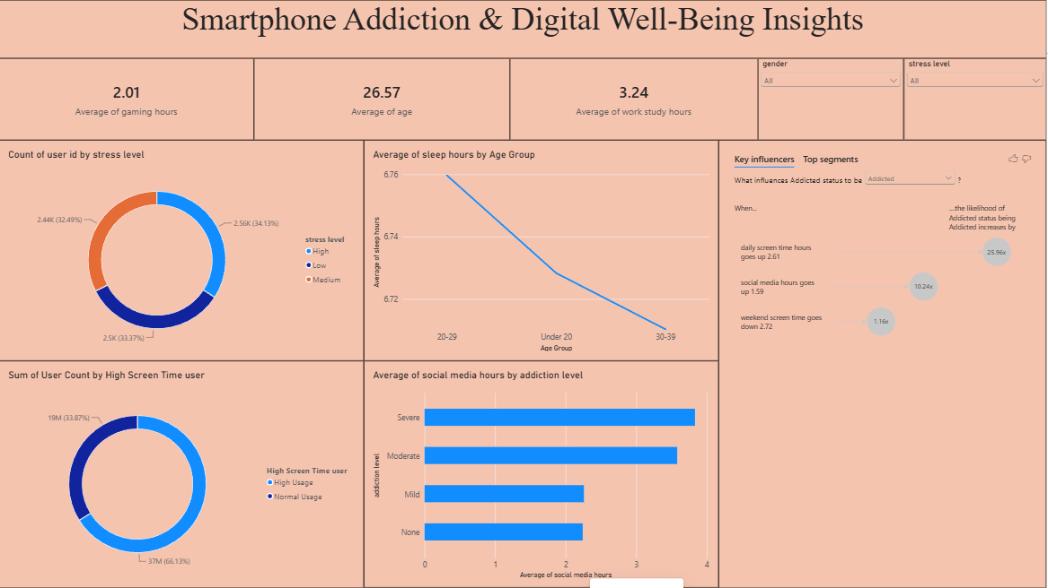

Visualization Insights:

The average gaming time is 2.01 hours, while average work/study time is 3.24 hours.

The average user age is 26.57 years.

High, medium, and low stress levels are distributed relatively evenly across the 7.5K users.

Average sleep hours vary slightly across age groups, with the 20–29 group showing the highest average sleep.

Users with severe addiction have the highest average social-media usage (3.8 hours), followed by moderate (3.6 hours), mild (2.3 hours), and no addiction (2.2 hours).

The Key Influencers analysis indicates that daily screen time is a major factor associated with addicted status; the dashboard shows a strong increase in the likelihood of being classified as addicted as daily screen time rises.

7. Performance Testing

7.1. Utilization of Data filters
The supplied dashboard includes three filter groups: gender, addiction_level, and Age Group. These filters allow users to narrow the dashboard and compare segment-level patterns.
Filter group | Displayed values/categories
Gender | Female, Male, Other
addiction_level | Mild, Moderate, None, Severe
Age Group | 20–29, 30–39, Under 20

7.2. No of Calculation Columns/Measures
The project reference explicitly identifies Age Group as a calculated field. The visuals also use standard Power BI aggregations such as Count, Average, and Sum for the displayed measures. The exact number of separately authored DAX measures is not provided in the supplied material, so it is not stated as a fixed number.
Type | Identified in supplied material | Purpose
Calculated field/column | Age Group | Supports age-segment analysis.
Count aggregation | user_id / addicted_label | Counts users and addicted classifications.
Average aggregations | age, screen time, social media, gaming, sleep, notifications, app opens, weekend screen time, work/study | Summarizes user behavior.
Sum aggregation | daily screen time and sleep in scatter visual | Provides the plotted aggregated values shown in the dashboard.

7.3. No of Visualization
Based on the supplied dashboard screenshots, the report contains 10 KPI cards plus 6 analytical charts, giving 16 visible dashboard visuals.
Visual category | Count | Examples
KPI cards | 10 | Addicted users, total users, age, screen time, social media, gaming, sleep, notifications, app opens, weekend screen time, work/study.
Analytical charts | 6 | Gender, addiction level, age group, screen/sleep scatter, addicted-label donut, gaming/social-media comparison.
Total visible visuals | 16 | KPI + analytical visuals shown in the supplied dashboard screenshots.

8. Conclusion/Observation
The Power BI analysis provides a consolidated view of smartphone usage and addiction classification across 7,500 users. The dashboard shows 5,308 users (70.77%) classified as addicted, an average daily screen time of 7.50 hours, average sleep of 6.74 hours, and substantial notification and app-opening activity. Moderate addiction is the largest category in the displayed addiction-level chart. The demographic charts show broadly similar average screen-time values across the displayed gender and age groups. The results provide a foundation for deeper segment-level investigation rather than establishing causal relationships.9. Future Scope
- Analyze addiction prevalence specifically by stress level, as identified in the project objectives.
- Compare addicted and non-addicted users across screen time, social-media hours, gaming, sleep, notifications, and app opens.
- Add trend or distribution visuals if timestamp or longitudinal data becomes available.
- Develop additional DAX measures for prevalence rates, segment comparisons, and behavioral differences.
- Add drill-through pages for individual segments such as gender, age group, and stress level.
- Introduce statistical/correlation analysis to distinguish simple association from stronger evidence of relationships.

10. Appendix

10.2. GitHub : https://github.com/Renusree123/Smartphone-Usage-Digital-Addiction-Well-Being-Analytics

Demo link: https://github.com/Renusree123/Smartphone-Usage-Digital-Addiction-Well-Being-Analytics/blob/main/7.Project%20Documentation%20and%20Demonstration/Project%20Demonstartion.mp4

